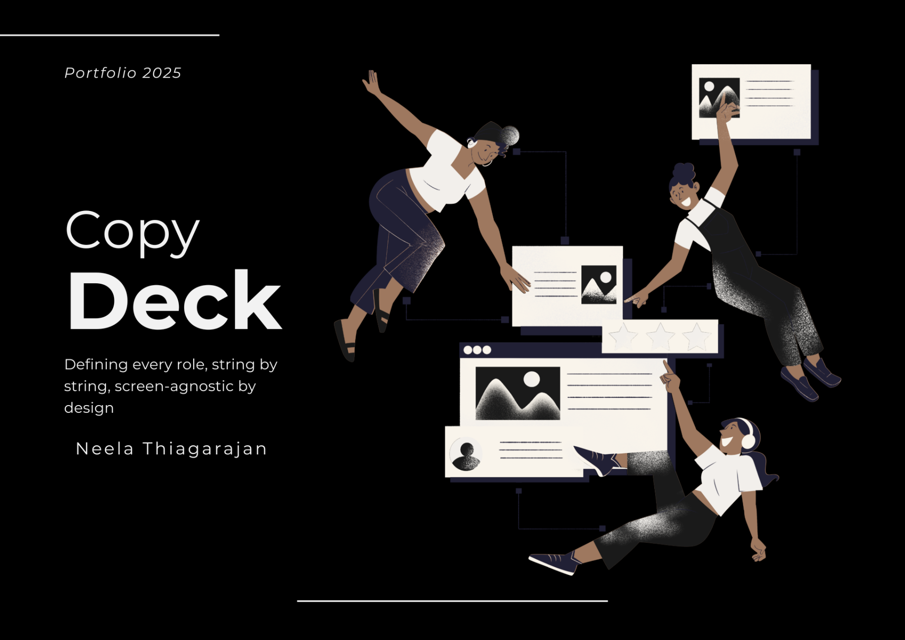

|  |  |
| --- | --- |
| **Document ID** | TCBRS_001_v2.0 |
| **Product** | Truist Commercial Banking (TCB) Platform |
| **Screen Name** | Role Selection |
| **URL Path** | /roles/select |
| **Content Architecture** | Screen-Agnostic |
| **String Count** | 48 Unique Strings |
| **Reusability Rate** | 93.75% |
| **Last Updated** | Apr 2025 |
| **Owner** | UX Copy Team |

## Stakeholder Approval

| **Role** | **Name** | **Date** | **Signature** |
| --- | --- | --- | --- |
| Content Strategist |  |  |  |
| UX Designer |  |  |  |
| Development Lead |  |  |  |
| Accessibility Lead |  |  |  |
| Legal/Compliance |  |  |  |
| Product Owner |  |  |  |

# Revision History

| **Version** | **Date** | **Author** | **Changes** | **Approved By** |
| --- | --- | --- | --- | --- |
| 1.0 | 10 Apr 2025 | Neela Thiagarajan | Initial draft |  |

# Terminology Guide

| **Term** | **Definition** | **Example** |
| --- | --- | --- |
| **String (Copy) ID** | Unique identifier for any text in the application | BTN_SUBMIT |
| **String Copy** | The actual text displayed to users | "Submit" |
| **String** | Any piece of text in the application (technical term) | Button labels, messages, titles |
| **Reusability** | Percentage of strings used across multiple screens | * Unique to this screen: 3 strings (6.25%) * Reused from other screens: 45 strings (93.75%) * Translation savings: 45 strings × 10 languages = 450 translations saved |
| **Tone** | The emotional quality and voice of the content | Helpful, Professional, Confident |
| **Intent** | The purpose and goal of the string | Guide user, Confirm action, Provide feedback |

# Screen Details

| **Screen ID** | **Screen Name** | **URL Path** | **String Bundle** |
| --- | --- | --- | --- |
| TCBRS_001 | Role Selection | /roles/select | BUNDLE_ROLE_SELECTION |

# Screen Layout

|  |  |
| --- | --- |
| **Desktop/Tablet View** | **Mobile View** |
| |  | | --- | | [HDR_BRAND_LOGO] | | [TITLE + SUBTITLE + TXT] | | [ROLE_CARDS × 3] | | [FTR_LEGAL + FTR_COPYRIGHT] | | [TOUR_CONTROLS - Fixed Position] | | |  | | --- | | [HDR_BRAND_LOGO] | | [TITLE_MAIN] | | [ROLE_CARD]  [ROLE_CARD]  [ROLE_CARD] | | [FTR_LEGAL] | | [TOUR - Bottom] | |

# String Registry

## Header and Footer Copy (Reusable Across All Screens)

| **Screen Element** | **String (Copy) ID** | **String Copy** | **Type** | **Tone** | **Intent** | **Max Length** | **Reuse Count** | **Accessibility** |
| --- | --- | --- | --- | --- | --- | --- | --- | --- |
| Logo | HDR_BRAND_LOGO | TRUIST | Image + Text | Professional | Brand identity | 10 | 127 screens | alt="Truist logo"<br>aria-label="Truist Bank homepage" |
| FDIC Badge | LEGAL_FDIC_BADGE | FDIC | Text | Formal | Compliance | 10 | 127 screens | aria-label="Member FDIC" |
| Footer Legal | FTR_LEGAL_DISCLAIMER | Truist Bank, N.A. Member FDIC. | Text | Formal | Legal requirement | 50 | 127 screens | role="contentinfo" |
| Footer Product | FTR_PRODUCT_NAME | Commercial Banking Platform | Text | Professional | Product identification | 30 | 52 screens | - |

## Page Header Copy (Shared with Other Role/Selection Screens)

| **Screen Element** | **String (Copy) ID** | **String Copy** | **Type** | **Accessibility** |
| --- | --- | --- | --- | --- |
| Page Title | TITLE_COMMERCIAL_BANKING | Commercial Banking | H1 | aria-label="Page title" |
| Subtitle | SUBTITLE_ROLE_SELECTION | Choose Your Role to Continue | H2 | - |
| Instructions | TXT_ROLE_SELECTION_INSTRUCTION | Select your role to access the appropriate dashboard and workflow designed for your responsibilities in the accounts payable process. | Text | - |

## Role-Specific Copy (Domain Strings, Reusable)

### Analyst Role Copy

| **Screen Element** | **String (Copy) ID** | **String Copy** | **Type** | **Accessibility** |
| --- | --- | --- | --- | --- |
| Card Container | - | [Interactive Container] | Container | role="button"<br>tabindex="0" |
| Icon | ICON_ROLE_ANALYST | [Clock/Workflow Icon] | SVG | alt=ALT_ICON_ROLE_ANALYST |
| Title | ROLE_ANALYST_TITLE | AP Analyst | H3 | - |
| Description | ROLE_ANALYST_DESC | Create and manage payments for vendors, contractors, and service providers. | Text | - |
| Feature 1 | FEAT_CREATE_PAYMENTS | Create one-time and recurring payments | List Item | - |
| Feature 2 | FEAT_BATCH_PROCESS | Process batch payments efficiently | List Item | - |
| Feature 3 | FEAT_PAYMENT_TRACKING | Track payment status and history | List Item | - |
| Feature 4 | FEAT_VENDOR_MANAGEMENT | Manage vendor profiles and details | List Item | - |
| CTA Button | BTN_ACCESS_DASHBOARD | Access Dashboard → | Button | aria-label=ARIA_BTN_ACCESS_DASHBOARD |

### Manager Role Copy

| **Screen Element** | **String (Copy) ID** | **String Copy** | **Type** | **Accessibility** |
| --- | --- | --- | --- | --- |
| Card Container | - | [Interactive Container] | Container | role="button"<br>tabindex="0" |
| Icon | ICON_ROLE_MANAGER | [Checkmark/Approval Icon] | SVG | alt=ALT_ICON_ROLE_MANAGER |
| Title | ROLE_MANAGER_TITLE | AP Manager | H3 | - |
| Description | ROLE_MANAGER_DESC | Review and approve payments with full oversight of team activities. | Text | - |
| Feature 1 | FEAT_PAYMENT_APPROVAL | Approve or reject pending payments | List Item | - |
| Feature 2 | FEAT_TEAM_METRICS | Monitor team performance metrics | List Item | - |
| Feature 3 | FEAT_AUDIT_TRAILS | Access comprehensive audit trails | List Item | - |
| Feature 4 | FEAT_WORKFLOW_MANAGEMENT | Manage approval workflows and policies | List Item | - |
| CTA Button | BTN_ACCESS_DASHBOARD | Access Dashboard → | Button | aria-label=ARIA_BTN_ACCESS_DASHBOARD |

### Compliance Role Copy

| **Screen Element** | **String (Copy) ID** | **String Copy** | **Type** | **Accessibility** |
| --- | --- | --- | --- | --- |
| Card Container | - | [Interactive Container] | Container | role="button"<br>tabindex="0" |
| Icon | ICON_ROLE_COMPLIANCE | [Shield/Security Icon] | SVG | alt=ALT_ICON_ROLE_COMPLIANCE |
| Title | ROLE_COMPLIANCE_TITLE | Compliance Officer | H3 | - |
| Description | ROLE_COMPLIANCE_DESC | Monitor risk patterns and ensure regulatory compliance across all transactions. | Text | - |
| Feature 1 | FEAT_RISK_MONITORING | Monitor risk patterns and anomalies | List Item | - |
| Feature 2 | FEAT_COMPLIANCE_REPORTS | Generate compliance reports | List Item | - |
| Feature 3 | FEAT_AUDIT_HISTORY | Audit transaction histories | List Item | - |
| Feature 4 | FEAT_REGULATORY_MANAGEMENT | Manage regulatory requirements | List Item | - |
| CTA Button | BTN_ACCESS_DASHBOARD | Access Dashboard → | Button | aria-label=ARIA_BTN_ACCESS_DASHBOARD |

## Interactive Elements (Reusable Tour System Copy)

### Tour Control Copy

| **Screen Element** | **String (Copy) ID** | **String Copy** | **Type** | **Accessibility** |
| --- | --- | --- | --- | --- |
| Start Button | BTN_TOUR_START | Start Tour | Button | aria-label=ARIA_BTN_TOUR_START |
| Toggle Button | BTN_TOUR_HOTSPOTS | Toggle Hotspots | Button | aria-label=ARIA_BTN_TOUR_HOTSPOTS |
| Skip Button | BTN_TOUR_SKIP | Skip Tour | Button | aria-label=ARIA_BTN_TOUR_SKIP |
| Next Button | BTN_TOUR_NEXT | Next | Button | aria-label=ARIA_BTN_TOUR_NEXT |
| Finish Button | BTN_TOUR_FINISH | Finish | Button | aria-label=ARIA_BTN_TOUR_FINISH |

### Tour Content Copy

| **Step** | **Title String (Copy) ID** | **Description String (Copy) ID** | **String Copy** |
| --- | --- | --- | --- |
| 1/5 | TOUR_TITLE_WELCOME | TOUR_DESC_PLATFORM_INTRO | **Title:** Welcome to Truist  **Description:** This is the Truist Commercial Banking platform. Our secure system helps manage your accounts payable workflow efficiently. |
| 2/5 | TOUR_TITLE_ROLE_ACCESS | TOUR_DESC_ROLE_ACCESS | **Title:** Role-Based Access  **Description:** Choose your role to access personalized dashboards. Each role has specific permissions and workflow features. |
| 3/5 | TOUR_TITLE_ANALYST | TOUR_DESC_ANALYST_ROLE | **Title:** AP Analyst Role  **Description:** Analysts create and manage payments, process batches, and maintain vendor relationships. Perfect for day-to-day payment operations. |
| 4/5 | TOUR_TITLE_MANAGER | TOUR_DESC_MANAGER_ROLE | **Title:** AP Manager Role  **Description:** Managers review and approve payments, monitor team performance, and oversee compliance. Includes advanced reporting and audit features. |
| 5/5 | TOUR_TITLE_COMPLIANCE | TOUR_DESC_COMPLIANCE_ROLE | **Title:** Compliance Officer Role  **Description:** Compliance officers monitor risk patterns, generate regulatory reports, and ensure all transactions meet compliance standards. |

## Link Registry (URL Mapping)

| **Link ID** | **String (Copy) IDs Using This Link** | **Destination** | **Type** | **Opens In** | **Business Rule** |
| --- | --- | --- | --- | --- | --- |
| LNK_HOME | HDR_BRAND_LOGO | /home | Internal | Same Window | Requires authentication |
| LNK_ANALYST_DASH | BTN_ACCESS_DASHBOARD (Analyst context) | /analyst/dashboard.html | Internal | Same Window | Requires Analyst role |
| LNK_MANAGER_DASH | BTN_ACCESS_DASHBOARD (Manager context) | /manager/dashboard.html | Internal | Same Window | Requires Manager role |
| LNK_COMPLIANCE_DASH | BTN_ACCESS_DASHBOARD (Compliance context) | /compliance/dashboard.html | Internal | Same Window | Requires Compliance role |

## System Message Copy (Reusable)

### Loading State Copy

| **State** | **String (Copy) ID** | **String Copy** | **Display Location** | **Accessibility** |
| --- | --- | --- | --- | --- |
| Card Loading | MSG_LOADING_DASHBOARD | Loading dashboard... | Replace card content | aria-live="polite" |
| Page Loading | MSG_LOADING_WORKSPACE | Preparing your workspace... | Full screen overlay | aria-busy="true" |

### Error Message Copy

| **Error Type** | **String (Copy) ID** | **String Copy** | **Display Method** | **Action String (Copy) IDs** | **Accessibility** |
| --- | --- | --- | --- | --- | --- |
| Network | ERR_NETWORK_FAILURE | Unable to load dashboard. Please check your connection and try again. | Modal | BTN_TRY_AGAIN, BTN_CANCEL | role="alert"<br>aria-live="assertive" |
| Session | ERR_SESSION_EXPIRED | Your session has expired for security. Please log in again. | Modal | BTN_LOGIN | role="alert"<br>aria-live="assertive" |
| Permission | ERR_PERMISSION_DENIED | You don't have permission to access this role. Please contact your administrator. | Inline Alert | BTN_CONTACT_ADMIN, BTN_CHOOSE_DIFFERENT | role="alert" |
| Browser | ERR_BROWSER_UNSUPPORTED | Please update your browser to continue. | Banner | BTN_LEARN_MORE | role="alert"<br>aria-live="polite" |

## Accessibility Copy Registry

| **String (Copy) ID** | **String Copy** | **Usage** |
| --- | --- | --- |
| ARIA_BTN_ACCESS_DASHBOARD | Open dashboard for selected role | Button aria-label |
| ARIA_BTN_TOUR_START | Start guided tour (5 steps) | Button aria-label |
| ARIA_BTN_TOUR_HOTSPOTS | Show or hide interactive indicators | Button aria-label |
| ARIA_BTN_TOUR_SKIP | Exit guided tour | Button aria-label |
| ARIA_BTN_TOUR_NEXT | Next tour step | Button aria-label |
| ARIA_BTN_TOUR_FINISH | Complete tour | Button aria-label |
| ALT_ICON_ROLE_ANALYST | AP Analyst role icon | Image alt text |
| ALT_ICON_ROLE_MANAGER | AP Manager role icon | Image alt text |
| ALT_ICON_ROLE_COMPLIANCE | Compliance Officer role icon | Image alt text |

### Screen Reader Announcement Copy

| **String (Copy) ID** | **String Copy** | **Context** |
| --- | --- | --- |
| SR_ANNOUNCE_FOCUS_NEXT | {Element name}, {type} | Tab navigation |
| SR_ANNOUNCE_FOCUS_PREV | {Element name}, {type} | Shift+Tab navigation |
| SR_ANNOUNCE_LOADING_ROLE | Loading {role} dashboard | Card selection |
| SR_ANNOUNCE_TOUR_CLOSED | Tour closed | Escape key in tour |
| SR_ANNOUNCE_TOUR_STEP | Step {n} of 5 | Arrow key navigation |

## Keyboard Navigation

### Tab Order (Using String (Copy) IDs)

1. Skip link (if present) - LNK_SKIP_TO_MAIN
2. Logo/Home - HDR_BRAND_LOGO
3. Role Cards (dynamic based on data)
4. Footer links (if any)
5. Tour controls - BTN_TOUR_START, BTN_TOUR_HOTSPOTS

### Key Commands

| **Key** | **Context** | **Action** | **Screen Reader String (Copy) ID** |
| --- | --- | --- | --- |
| Tab | Any | Next focusable element | SR_ANNOUNCE_FOCUS_NEXT |
| Shift+Tab | Any | Previous focusable element | SR_ANNOUNCE_FOCUS_PREV |
| Enter/Space | Role Card | Navigate to dashboard | SR_ANNOUNCE_LOADING_ROLE |
| Escape | Tour Active | Close tour | SR_ANNOUNCE_TOUR_CLOSED |
| Arrow Keys | Tour Active | Navigate steps | SR_ANNOUNCE_TOUR_STEP |

## Translation Requirements

All String (Copy) IDs require translation except:

* Brand names (within HDR_BRAND_*)
* Legal entity names (within LEGAL_* when proper nouns)
* Technical URLs
* Icon file references